Enter Hours/Pay Transmittals

To Enter Hourly Employees for Pay Type 3

a. Create Hours

Payroll > Maintenance > Hours/Pay Transmittals > Create Hours

- Select the Pay Date
- Click Retrieve
- Hours: Select Regular.
- All Hourly employees will appear on this screen.
- Enter the Reg Hours
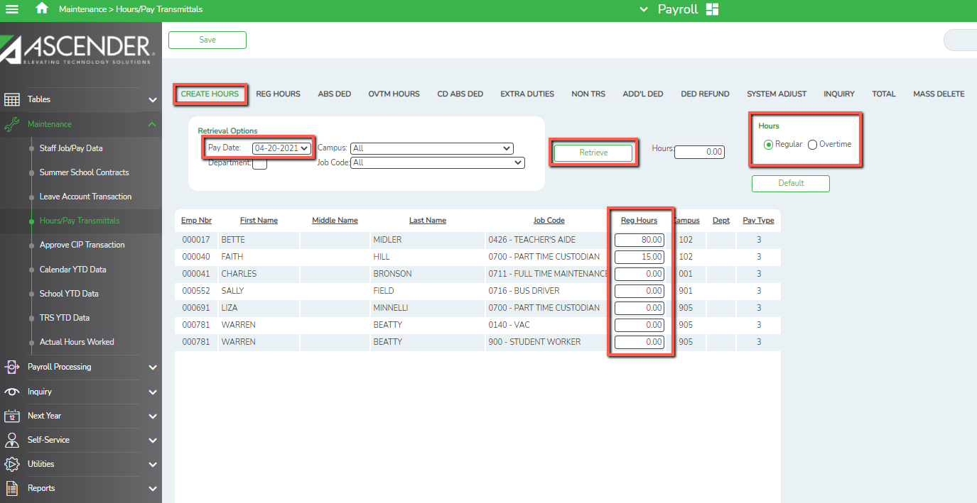
- Click SAVE.

b. Reg Hours: Continuation of Entering Hourly Employees –

Payroll > Maintenance > Hours/Pay Transmittals > Reg Hours

- Select Paydate and Retrieve
- Edit Regular Hrs,
- Actual Hrs
- Actual Date
- Click SAVE

NOTE: Save information entered on each tab before leaving the tab.

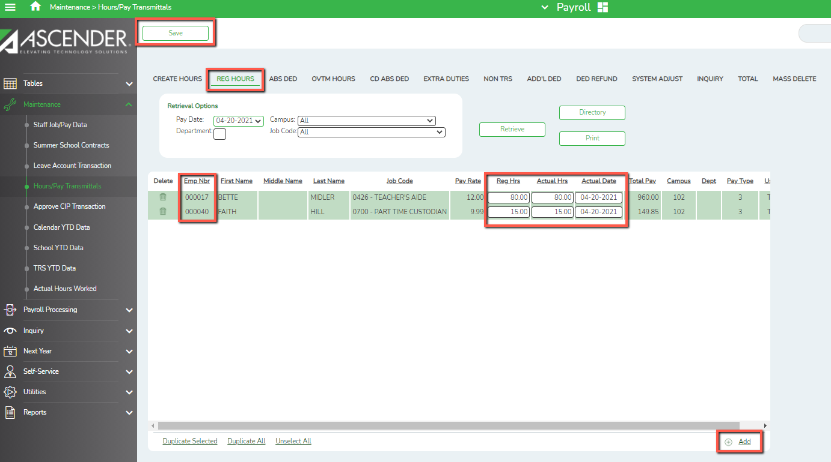

c. Overtime hours for Pay Types 2 & 3
Payroll > Maintenance > Hours/Pay Transmittals > Create Hours
- Select the Pay Date
- Click Retrieve
- Hours: Select Overtime
- All Overtime employees will appear on this screen.
- Enter the Overtime Hours
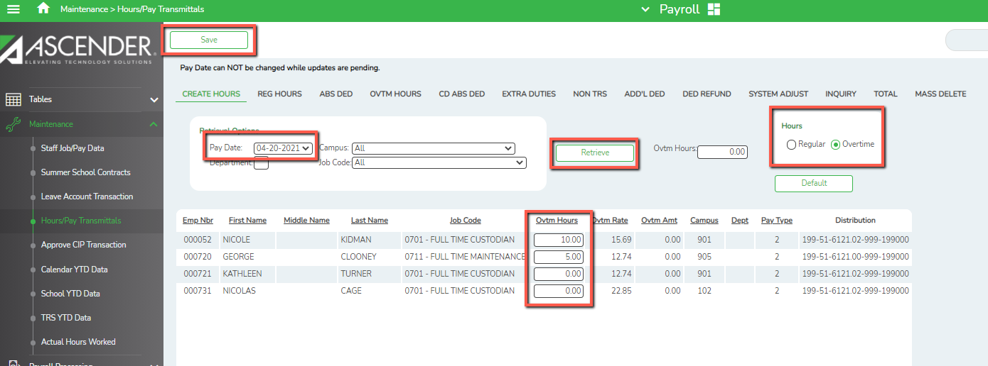
- Click SAVE

d. Overtime Hours: Continuation of Entering Hourly Employees –

Payroll > Maintenance > Hours/Pay Transmittals > Overtime Hours

- Select Paydate and Retrieve
- Edit Ovetime Hrs,
- Actual Hrs
- Actual Date
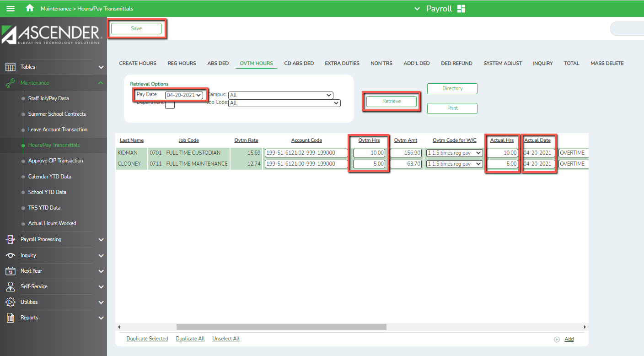
- Click SAVE

e. Extra Duties - All Pay Types: Example: Gate, Time Clock keeper at Gate, ISS,
Tutorials, Substitutes not tied to an employee etc.
Payroll > Maintenance > Hours/Pay Transmittals >Extra Duties
- Enter the Emp Nbr or choose Directory if unknown, then TAB
- Enter Extra Duty Code if applicable
- Enter the Account Code
- Extra Duty Amt. or Substitute pay
- Actual Hrs
- Actual Date
- Reason for the Extra Duty
- Click SAVE

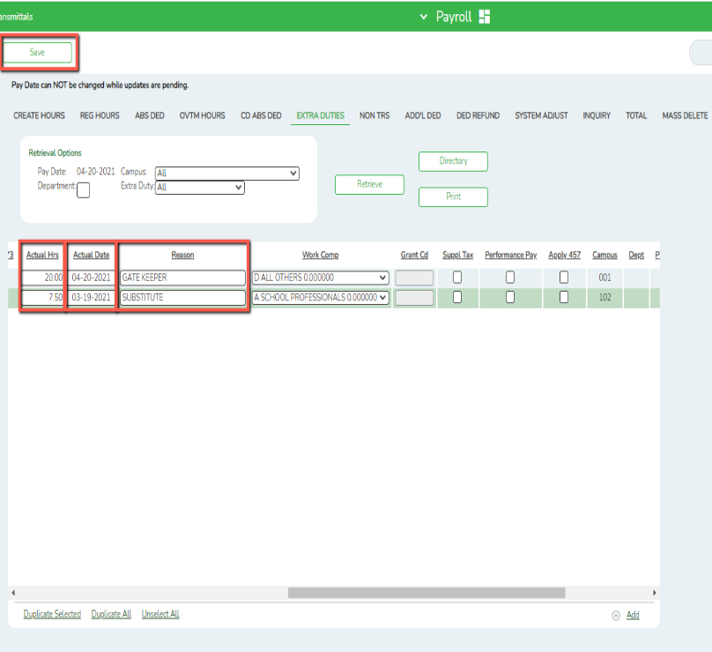
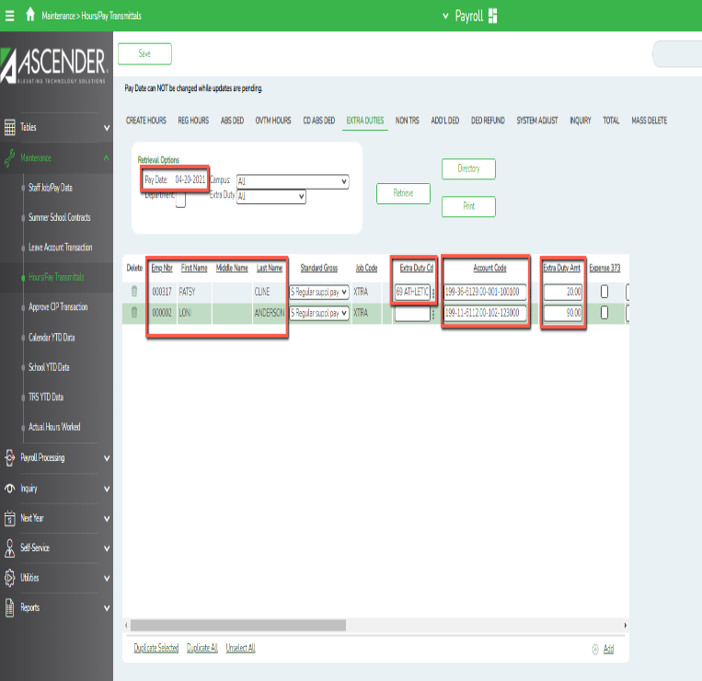
- Non-TRS – All Pay Types
Maintenance > Hours/Pay Transmittals > Non TRS
Example: Employees who receive non-TRS supplemental pay amounts such as travel and uniform allowances and TRS ActiveCare allowances taken as compensation. Nontaxable amounts also are not included in unemployment, FICA, TRS, and withholding tax calculations

- Enter the Emp Nbr or choose Directory if unknown, then TAB
- Verify or Enter the Account Code
- Payment Code: Click to select whether to pay not pay

Example:
- If N Do not pay is selected, the Payment Type field automatically is set to 2 - Non TRS Bus Allow, and the user cannot modify. Transactions using this combination will not display on the Account Distribution Journal, but are displayed on the Payroll Earnings Register, Check Stub, and Calendar YTD report.
- If you are reimbursing an employee for a meal during travel, you will select Payment Code Y to pay the employee.
- If however, the employee used a school credit card so you don’t have to reimburse him, but do need that reimbursement on his W-2, select Payment Code N so the amount is not added to his paycheck.
- Choose the Type of Payment and enter the amount in Taxable or Non-Taxable as applicable. Enter a reason for the Non TRS amount
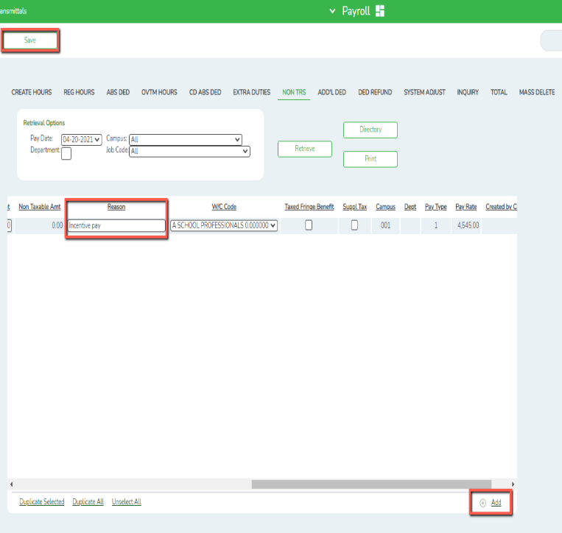
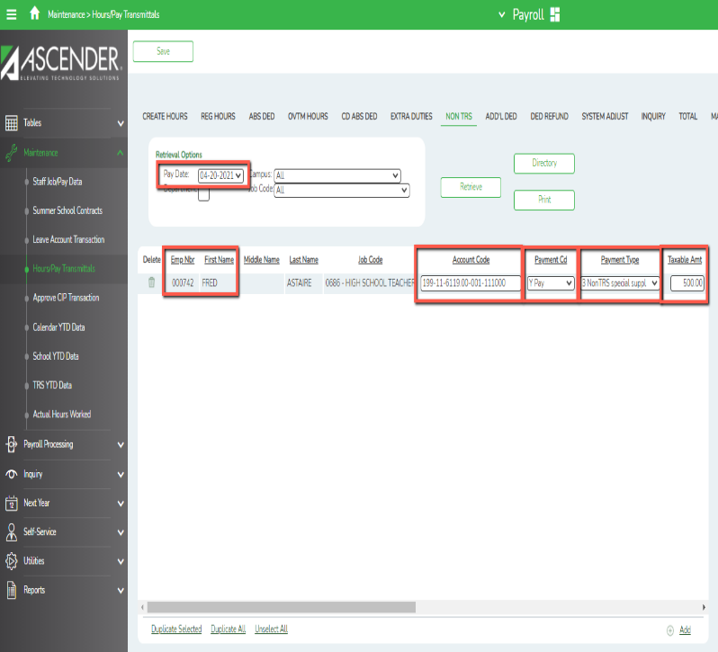

- Additional Deductions – All Pay Types

Payroll > Maintenance > Hours/Pay Transmittals > Additional Deductions
This tab is used to maintain records of additional deduction transmittals from employee paychecks. It allows the user to set up one-time deductions without altering deduction information on the employee master record.

NOTE: Entries on this page are not processed when selecting Supplemental Payroll on the Run Payroll process page. They are only processed with regularly scheduled payroll processing.

- Enter the Pay date
- Click Retrieve
- Enter the Emp Nbr or choose Directory if unknown, then TAB
- Enter the Deduction Code
- Select the Deduction Type
- Enter the Deduction Amount
- Select Café 125 if the deduction should be tax sheltered
- Enter the Reason for the Deduction
- Click SAVE
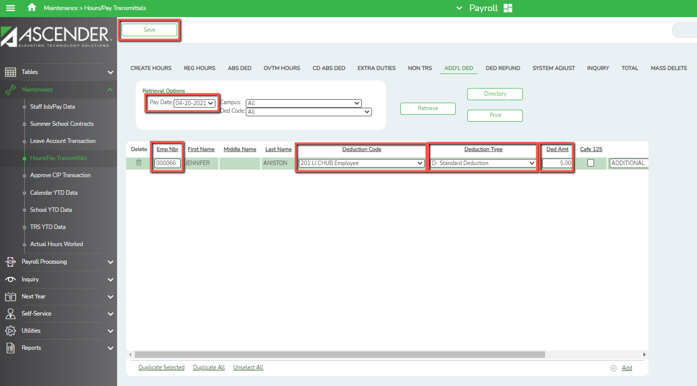

- Deduction Refunds – All Pay Types
Maintenance > Hours/Pay Transmittals > Deduction Refunds
This tab is used to maintain records of deduction refund transmittals for employee paychecks in which incorrect deductions were taken. This tab is used for correcting deduction errors.

- Enter the Pay date
- Click Retrieve
- Enter the Emp Nbr or choose Directory if unknown, then TAB
- Enter the Deduction Code
- Enter the Deduction Refund Amount
- Select Café 125 if the deduction was originally tax sheltered
- Enter the Reason for the Refund
- Click Save
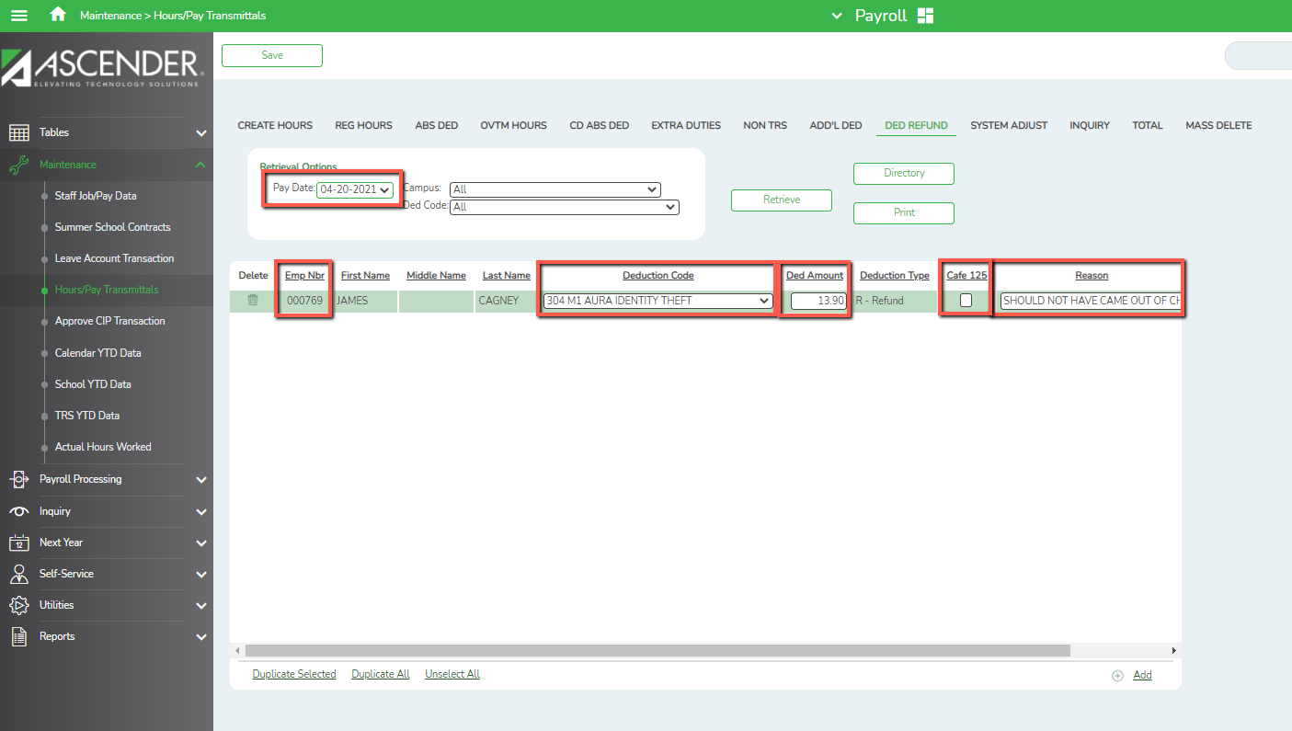
- System Adjustments – All Pay Types
Maintenance > Hours/Pay Transmittals > System Adjustments
Used to refund particular contributions normally taken during the payroll process. Select the Refund Type and enter the amount. In the Gross Amt field, type the employee’s gross monthly salary according to the refund type.
- If the refund type is TRS related (i.e., refund types I, P, S, or T), enter the TRS gross amount.
- If the refund type is Medicare related (i.e., refund type M), enter the Medicare gross amount.
- If the refund type is FICA related (i.e., refund types F or G), enter the FICA gross amount.
NOTE: Only process during Regular Payroll and not Supplemental.
